Project Design Phase-II
Technology Stack (Architecture & Stack)
Date | 25-06-25
Team Id | LTVIP2025TMID47835
Project Name | Resolver
Maximum Marks | 4 Marks
Technical Architecture:
The Resolve Now platform is designed with a scalable 3-tier architecture that includes the presentation layer (frontend), business logic (backend), and data storage layer. The solution ensures performance, security, and ease of integration with third-party APIs (e.g., Stripe for payments).
Table-1 : Components & Technologies:
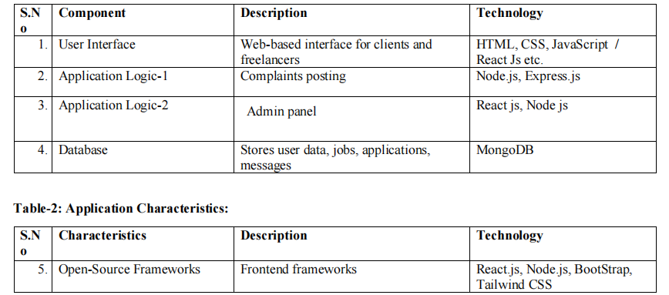
References:
React.js Documentation
Node js Best Practice
JSON Web Server Reference
https://medium.com/the-internal-startup/how-to-draw-useful-technical-architecture-diagrams-2d20c9fda90d

